PROJECT 1 : PRELIMINARY ANALYSIS

Ryan Dockstader

# Target User

My target user is customers of Main Street Guitars. This is a local guitar shop that I really like, but they don’t have a very usable website. The typical user of this website would be someone local to my city that enjoys guitars, and wants to know the pricing, specs, and see some pictures of the guitars at the local guitar shop.

# Current Interface

Right now the only way to really see their guitars is to look at their Instagram. Unfortunately, this doesn’t show all current stock, and some of the guitars in the photos have already been purchased.

Link: <https://loganbooktable.wordpress.com/2016/09/26/main-street-guitars/>

Website:



Instagram: <https://www.instagram.com/main_street_guitars/>

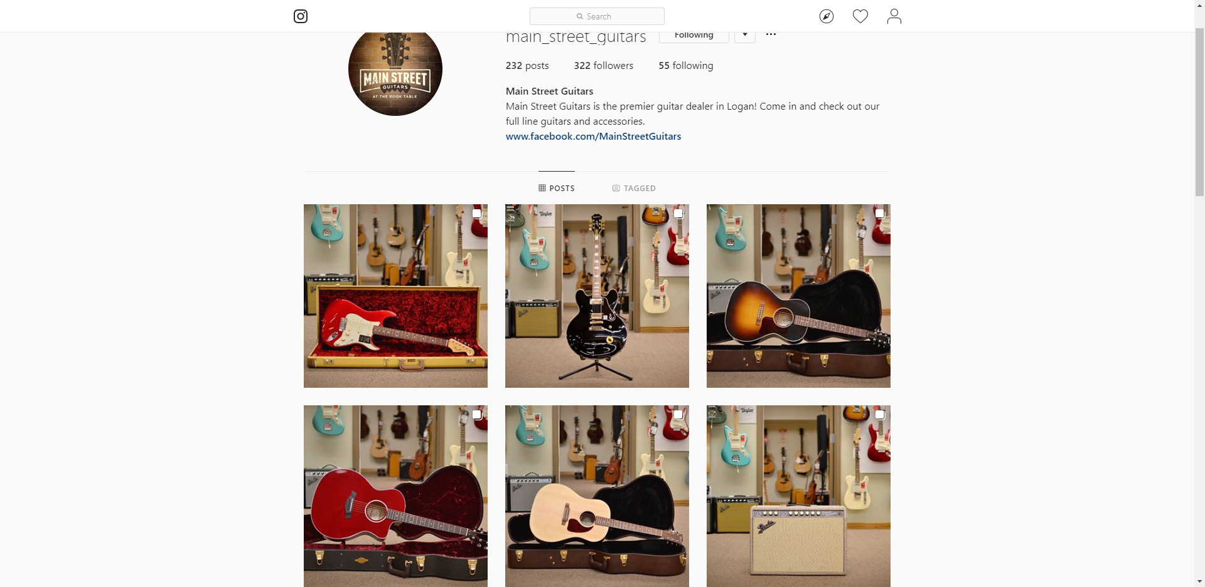

# Components of the Interaction Framework

## Presentation

Guitars should be presented to the user, with the current stock, colors, and price. Currently a very limited amount of these are shown on their Instagram profile, and not at all on their web page.

## Perception

The current website doesn’t allow the user to perceive any data about the guitar store, other then it’s a guitar store. This is a huge problem if you’re wanting to show your stock on the internet, and not just showcase a few guitars.

## Interpretation

This is hard one, as there isn’t a lot of components on the interface. When I first found the site, I was expecting to see at least a few of their guitars. Unfortunately, I didn’t find any. Luckily, I was able to locate their Instagram page to see a very limit number of what they have. However, when I went to look at one of them it was already sold.

## Evaluation

The goal of the user doesn’t have really any relationship to the components on the current website.

## Goal

To view the stock of the local guitar shop, in preparation of a potential purchase

## Intention

Go to the website, filter guitars, see prices, and view pictures of the current stock

## Specify Sequence

1. Navigate to the website in a browser
2. See a listing of the current stock of guitars, with pictures and prices
3. Filter a larger list of guitars into a smaller list of guitars based on make, model and price range
4. Drill into a guitar to find more information about the guitar
5. Potentially make a purchase.

## Execute Sequence

There are currently no interface elements to execute the goal. They all need to be added.

# Variables of Usability

## Efficiency

You are currently unable to perform the task.

## Learnability

You cannot become proficient in the task, as there is no option to get the task done

## Familiarity

The design really doesn’t resemble anything

## Simplicity

It is pretty simple. But you also can’t accomplish the goal.

## Mapping

There is no mapping, as there is no interface.

## Motivation

There is no motivation to use the interface.

## Trust

There is no trust in the interface.

## Visibility

There is no visibility aspect to the interface.

# Rubric

|  |  |  |  |  |  |
| --- | --- | --- | --- | --- | --- |
|  | Exceptional 100% | Good 90% | Acceptable 70% | Developing 50% | Missing 0% |
| Selection Criteria 20% | It is clear the interface is important to the user and the user could benefit from a better design | All the components are present and the project is doable | All the components (user, interface description, and picture) are present but the project might be very difficult to complete | Example missing description of user, description of the interface, or a picture of the interface | No item selected |
| Interaction Framework: Correctness 10% | It is "abundantly clear" that the interaction framework is fully understood | No errors in the listing nor defining the steps | One component of the interaction framework is incorrectly defined | Two components of the interaction framework are incorrectly defined | Three or more components of the interaction framework are incorrectly defined |
| Interaction Framework: Evaluation  20% | The interaction framework was used to correctly identify the core of the usability problem for the example | No mistakes were made in evaluating the example using the interaction framework | Analysis according to the interaction framework was inaccurate in one way | Analysis according to the interaction framework was inaccurate in two or more ways | The interface was not evaluated according to the interaction framework |
| Variables of Usability: Correctness  20% | It is "abundantly clear" that the variables of usability is fully understood | No errors in the listing or defining the variables | One variable is incorrectly defined | Two variables are incorrectly defined | Three or more variables are incorrectly defined |
| Variables of Usability: Evaluation  30% | The variables of usability were used to correctly identify the core of the usability problem for the example | No mistakes were made in evaluating the example using the variables of usability | Analysis according to the variables of usability was inaccurate in one way | Analysis according to the variables of usability was inaccurate in two or more ways | The interface was not evaluated according to the variables of usability |